## AYALA ALABANG R1P

1.9 Grounding system study

The study has been conducted in accordance with the ITP. Some representative pictures during measurement are shown in Figure 1.21.

Results of the study are shown in Table 1.22 with the following notes:

* The resistance between the main grounding electrode and ground should be no greater

than five ohms for large commercial or industrial systems and 1.0 ohm or less for generating or transmission station grounds unless otherwise specified by the owner. (Reference

ANSI/IEEE Standard 142)



Figures : Grounding test points and values

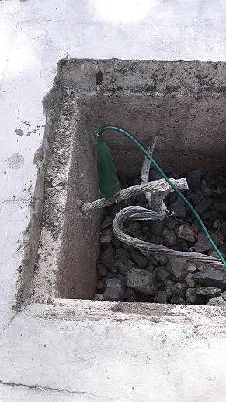 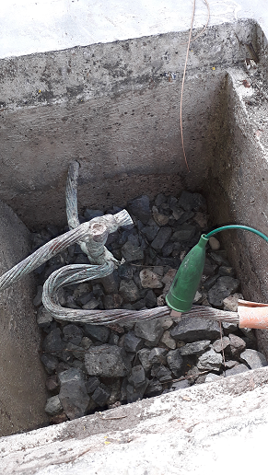 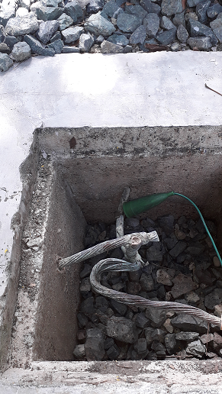 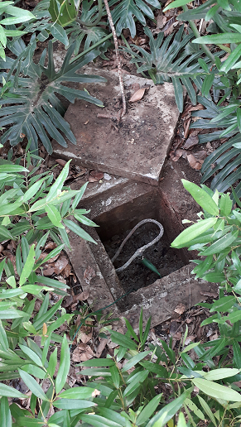

(a) Test point#1 (b) Test point#2 (c) Test point#3 (d) Test point#4

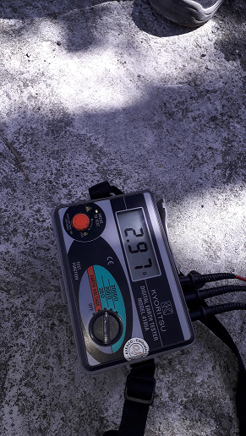 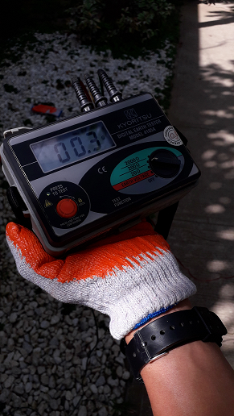

(e) Value test point#1 (f) Value test point#2